Donation Request

San Diego House Rabbit Society (SDHRS) is an all-volunteer, nonprofit animal welfare organization that rescues abandoned domestic rabbits in San Diego and southwest Riverside counties. For more than 20 years, SDHRS has supported our community in caring for domestic rabbits and their caretakers.

Bunnyfest is our annual fundraiser that helps us to earn funds needed to continue our work. Our event is a fun, bunny-themed open-air faire that includes craft vendors, service booths (vets and other animal services), a silent auction, children’s activities, and more. The day also includes games for rabbits and their people, refreshments, and sharing fun with other bunny lovers.

Bunnyfest supports the following accomplishments:
- Spay or neuter of more than 300 rabbits, each year, from local shelters and in SDHRS foster care
- Medical care, including lifesaving surgeries to foster and shelter rabbits
- A spay/neuter rebate that gives financial compensation to individuals who get their rabbit altered
- Support of nine shelters/humane societies in San Diego and Riverside counties. We provide supplies, cages, pellets/hay, litter boxes and more.
- Community education at events throughout the county, and in-house classes on rabbit care and popular rabbit behavioral or health issues
- Participation in HRS-wide large rescues that save hundreds of rabbit lives from locations throughout the U.S.

Today, we are requesting your support of our event. We need donations of items or services for our silent auction. Auction items typically include a personal service, hotel stays, event tickets, a rabbit-themed craft item or painting, restaurant certificates, rabbit-themed jewelry, and so on. Autographed sports memorabilia are also popular. Anything rabbit-related will be of interest, but we ask that the rabbit not be “clothed” as it goes against our organization’s philosophies.

Donations can be sent to: SDHRS Auction, 8055 El Capitan Drive, La Mesa, CA 91942. If you are local and would like a pick-up arranged, please email patricia@sandiegorabbits.org and we will have a volunteer stop by. If you have questions, please don’t hesitate to call us at 619-865-1294.

Thank you so much for your support of Bunnyfest and San Diego House Rabbit Society.

Sincerely,

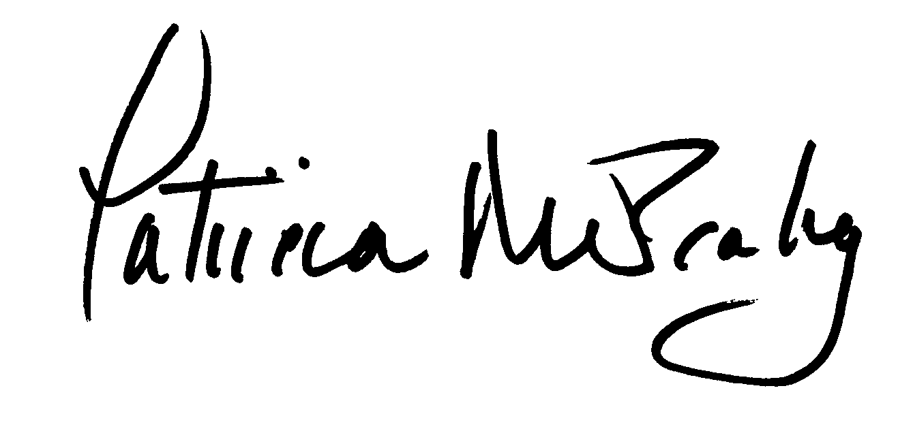
Patricia Mulcahy
President

Please return a copy of this letter with your donation and keep a copy for your records. Your donation is tax-deductible to the extent allowed by law.

Item donated: _________________________________________________________________ Value: _______________

